Programming a Local Road Job in JobNet
12-8-20
Table of Contents
Create Page…………….1
Asset Layers Page…...2
Prerequisite Page…….5
Job Page………………….5
Asset Page………………9
Phase Page……………..12
S/TIP Page……………… 18
Attachments Page….19

Create Page
Log into JobNet and make sure that you are on the homepage.
Open the “Create” page
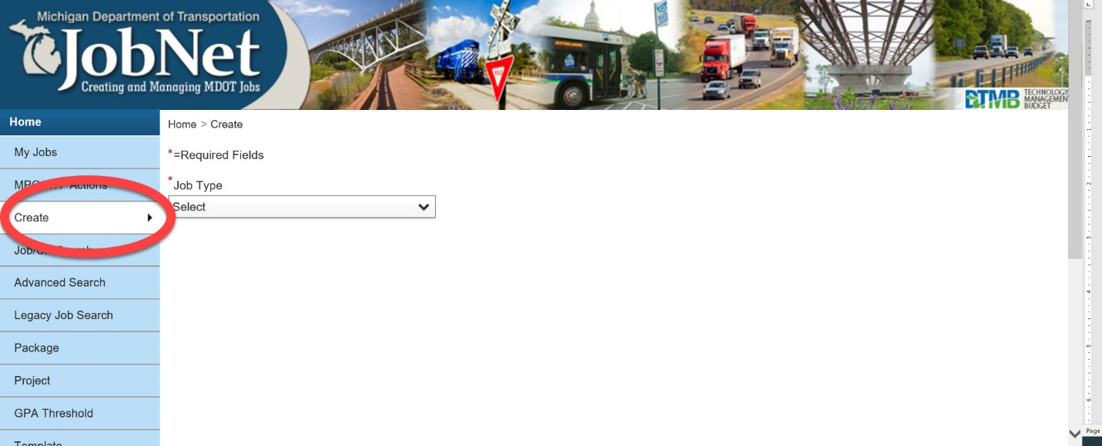
Under the “Job Type” dropdown menu, select “Local”

Choose “Construction” and click “Next”
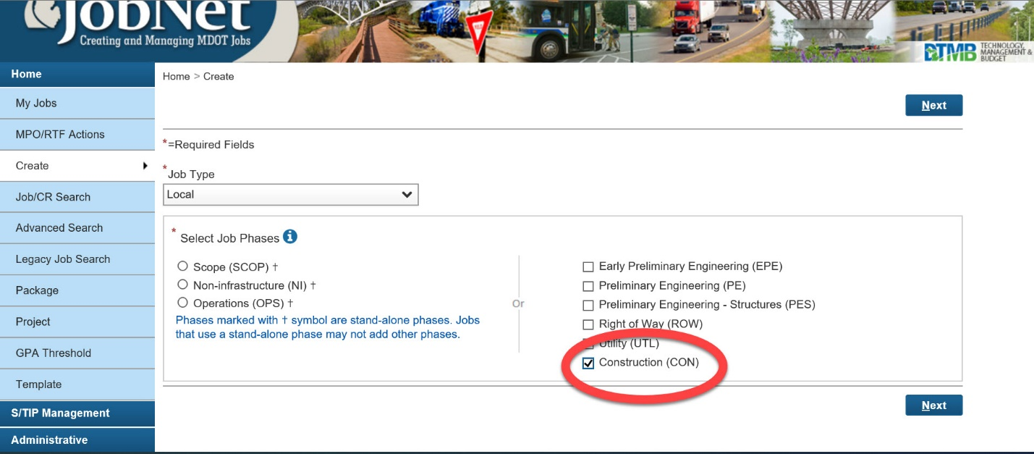
The Asset Layers page will appear

Asset Layers Page
Under “Asset Layers” on the left side column, Choose “Local Segments” (the second one down).
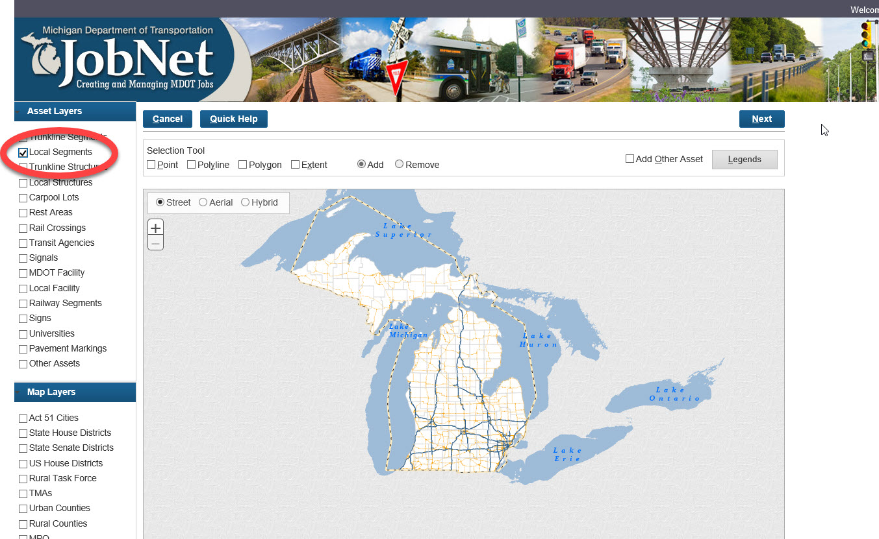

Zoom into the area on the map where the job will be.
Under “Selection Tool” above the map, select “Point” and “Add”
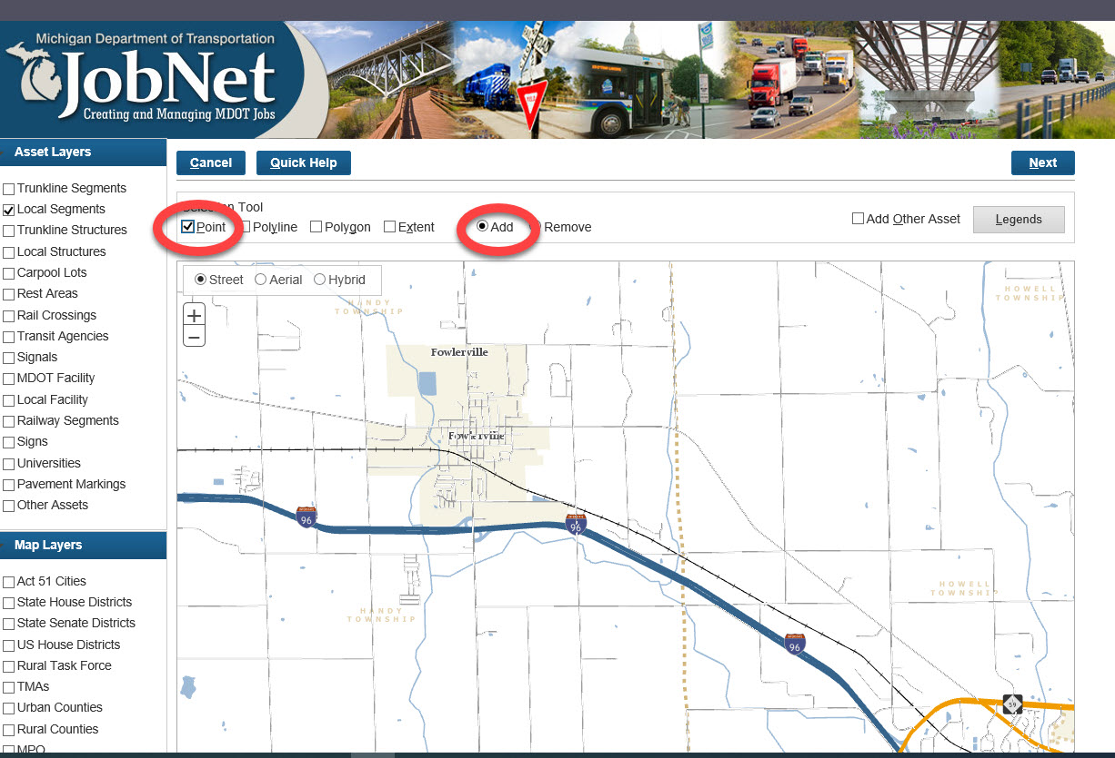

Click on each of the road segments that make up the total extent of the job limits.

If you are unsure of where the project is located and the PR# and mile points are provided on the 1799, you can go to the PR finder map and enter the PR# and you can see the general location of the project. You will then need to program it in the asset page. https://www.mcgi.state.mi.us/prfinder/
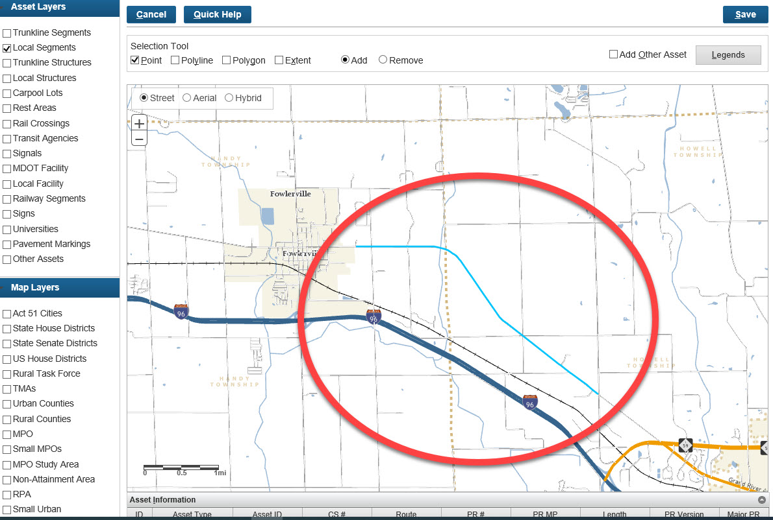
If a segment needs to be split to make the map more accurate for this job, this process will be explained later in the “Asset Page” section of this information sheet.
Below the Map in the “Asset Information” area Click on “Major PR”
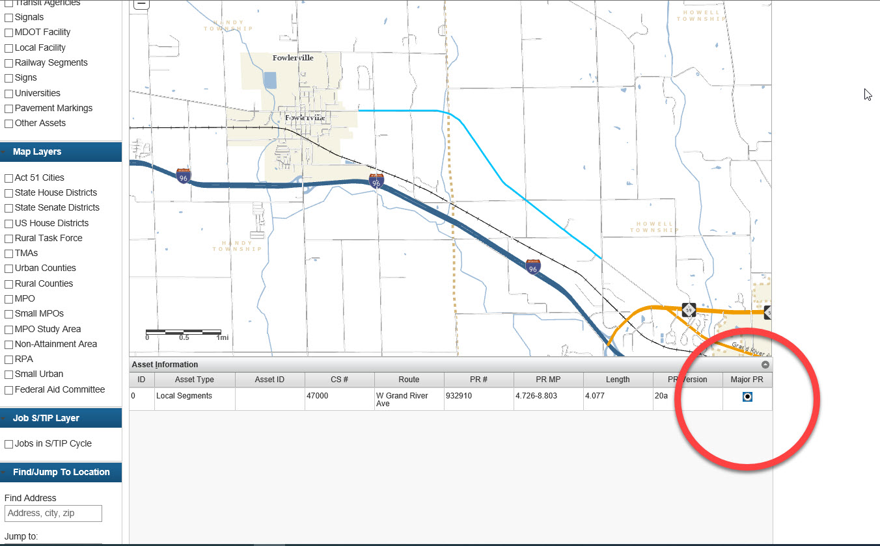
At the bottom and top of the page, are two Save Buttons. They both do the same thing. Clicking “Save” will create the Job Number. Write this number down, it only appears for a few seconds, but will also appear at the top of the next page if you miss it.
Click “Next” to go to the Prerequisite Page
Prerequisite Page
Fill in the Prerequisites according to the specific job. This information can be found on the 1799 form.
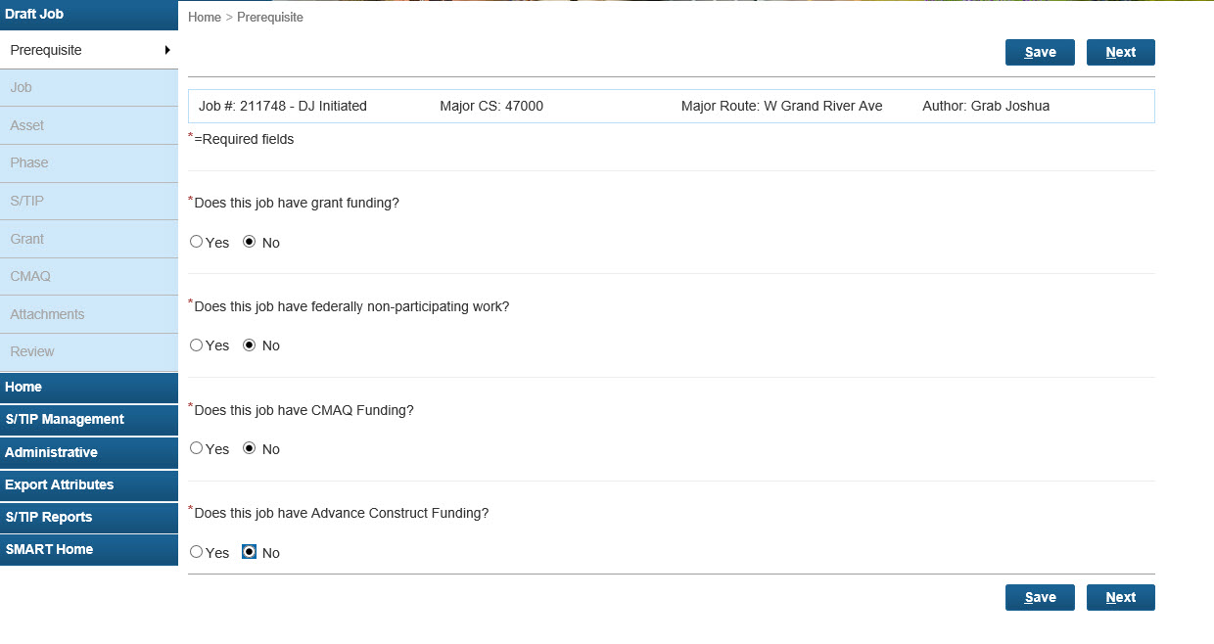12. Click “Next” at the top or bottom of the page and the Job Page will open.
Job Page
The information for this page will come from the 1799. The top section of this page will be automatically filled in.
“Major Route” will be filled in automatically based on the “Major PR” that was chosen in the Asset Layers Page and cannot be edited.
General Info
“Job Type” should be filled in already
“Project Manager” can be left blank, for these projects this will be the Rural Area Staff Engineer from MDOT LAP that is assigned to the county this job is located in.
“Major Route (Report)” will also be filled in automatically based on the major route chosen on the asset page but it can be edited. This is the route that will show on all of the JobNet reports. In the case of an Areawide or Various Routes project this should be changed to “Areawide” or “Various Routes”
Work Type
Start with “Major Work Type” on the right side of the page and the other fields on this line will back fill with the correct information. This is found directly above the budget information on the 1799.
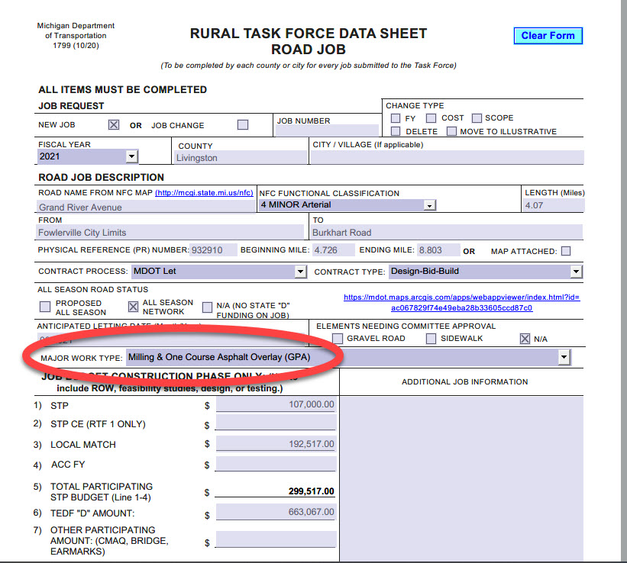

Contract Information and Dates
“Contracting Process” and “Contract Type” are found in the middle of the 1799. Most of the time these are “MDOT Let” and “Design-Bid-Build”.
“Contract Indicator” will be “Not Applicable” in most cases.
“Con Phase Recommended Fiscal Year Obligation” is toward the top of the 1799 under “Fiscal Year”.
“Con Phase Recommended Fiscal Year Obligation Quarter” should be two months before the “Anticipated Letting Date” on the 1799.
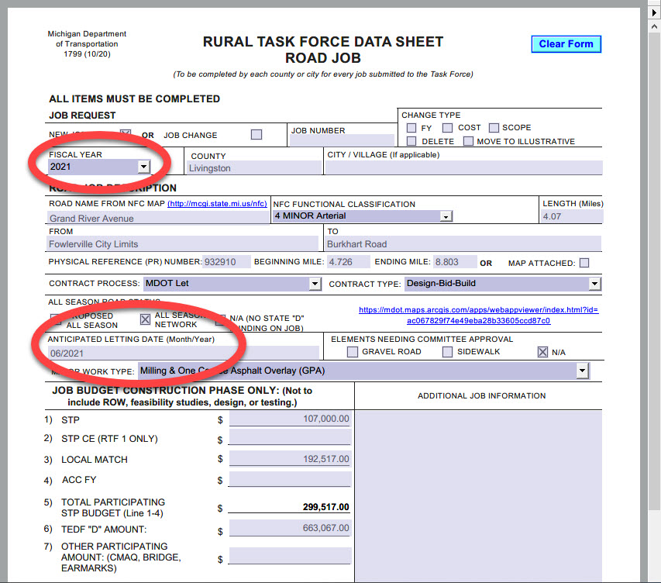“Recommended Let Date” is the “Anticipated Letting Date” on the 1799. Use the calendar to select the date. Select a date that is black and in bold for Design-Bid-Build jobs. The Blue dates are for Fixed Price Variable Scope jobs.
“Scheduled Plan Completion Date” should be filled in automatically by JobNet. If it is not, fill this in with a date that is three months before the “Anticipated Letting Date” on the 1799.
The “Recommended Let Date” and “Recommended Plan Completion Date” may cause a warning from JobNet. If the warning is in yellow, it can be ignored for now. The most important thing is that the “CON Phase Recommended Fiscal Year Obligation” is filled in with the correct FY for this job.
Location Description
The first three selections of: “Region”, “TSC”, and “Entity” should be filled in already.
“Agency Type” will be “County” or “Municipality” for RTF road jobs.
“Agency Name” is the county or city/village name specific to this job. Start typing it and then choose it from the dropdown menu.
“Location (Report)” is a brief title or name for this job that will show up in MDOT reports. The road name from the “Major Route (Report)” at the top of the Job Page and the “From” and “To” crossroads from the 1799 should be put here. Please spell out all abbreviations such as: North, West, Street, Road, Avenue, etc. If the job has multiple segments it should be listed as “Various locations – (County/City Name)”.
“Location (Detailed)” should provide further explanation of this job including the job limits. An example would be “Grand River Avenue from the Fowlerville City Limits to Burkhart Road”. Please continue to spell out all abbreviations such as: North, West, Street, Road, Avenue, etc. If the Job has multiple segments, they should all be described here. On the 1799s multiple segments should be listed in the “Additional Job Information” area next to the job funding. This is a common place to explain all of the locations that are part of an areawide job. FHWA will see the “Location (Detailed)” field directly.
There is a help document on the JobNet home page called FHWA Guidance: Project Title and Description with the FHWA requirements for location and work description.

Work Description
“Work (Report)” can be taken directly from the “Major Work Type” on the 1799.
“Work (Detailed)” This is a place to further explain the project. On Some 1799s there will be detailed work in the “Additional Job Information” area next to the job funding. This is a common place to expand on the work being done. FHWA will see this directly. Please continue to spell out all abbreviations such as: North, West, Street, Road, Avenue, etc. If nothing is put here, the “Work (Report)” from above will duplicate itself.
Justification
“Justification”, something must be in this field. The “Sub-category” under “Work Type” at the top of this job page is acceptable. Example- “Road Capital Preventative Maintenance”

Here is a completed example of a Job Page;
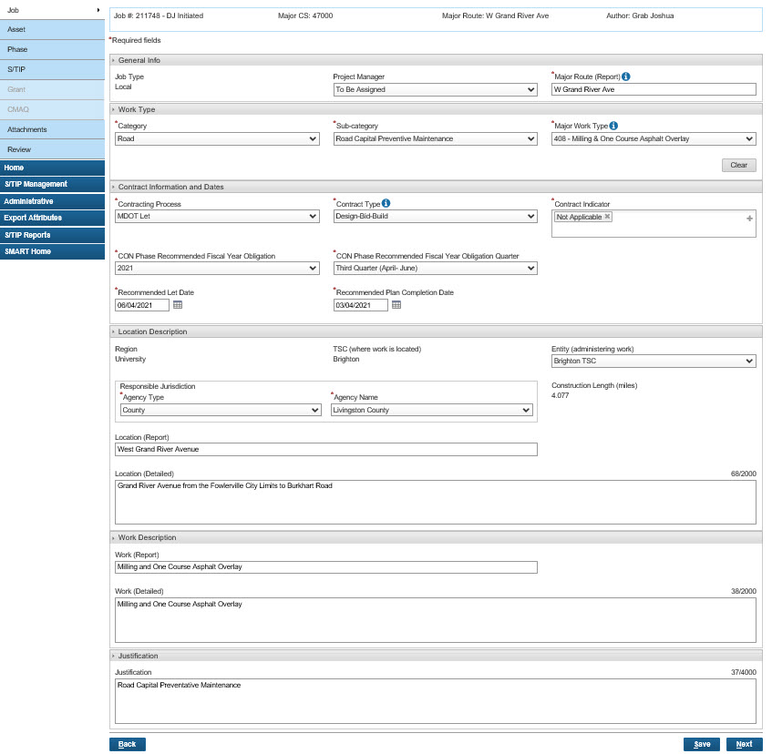Click “Save” then “Next”
Asset Page
This is where a segment of the map can be split to make the map more accurately represent the job’s limits. If nothing more specific is needed, please look this page over and click “Next” to go onto the “Phase Page”

To Edit the Map / Split the Road Segments:
Click on “Edit Assets” at the top of this page.
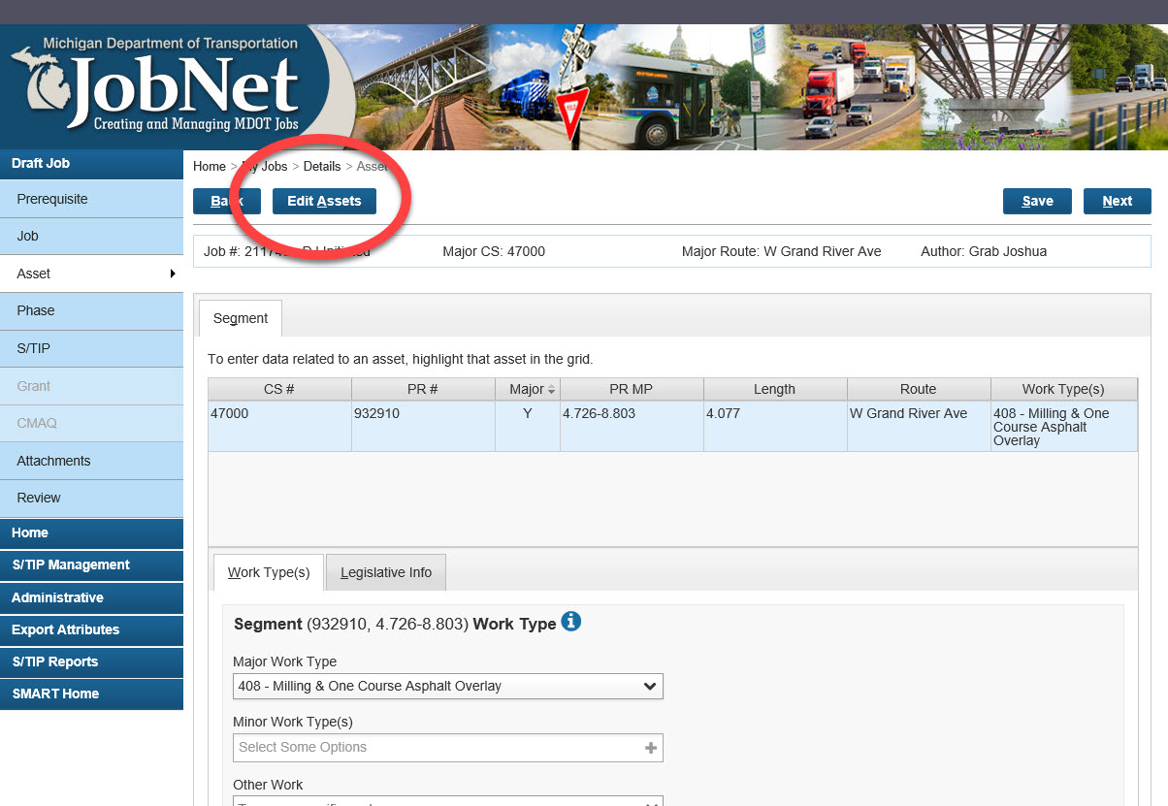On the right side on the map, under the “Road Segment Information” select either “Field” or “Map”
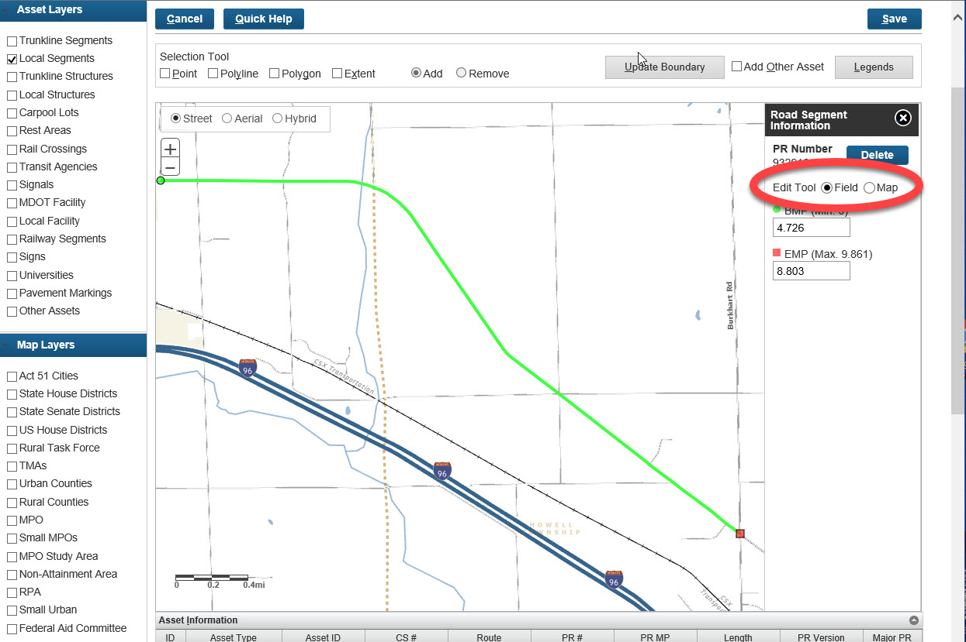

“Field” will allow you to type the exact mile points in. They can be found on the 1799 above the “Contract Process” section. To do this, select “Field” then click in the box containing numbers under BMP or EMP, and insert the correct mile points.
“Map” will allow you to edit the mile points directly on the map. To do this, select “Map” then zoom into the beginning or end of the job segment, depending on the mile point you wish to edit (segment). Next, click the “Select” box under BMP or EMP. Lastly, move your cursor to the desired location on the map, and click that location to make it the new mile point. You will see the new mile points appear under the cursor arrow as you move it around the map before you make the selection by clicking.
Click “Save” in the upper right or lower right of the map, then “Next”.
This takes you back to the Asset Page. Click “Next” to go to the Phase Page.
There is a help document on the JobNet home page called Using the JobNet Map that describes all the asset map functionality.

Phase Page: Budget Tab
Check to make sure that “Con” is under “Phase” in the top line under “Phase Budget”
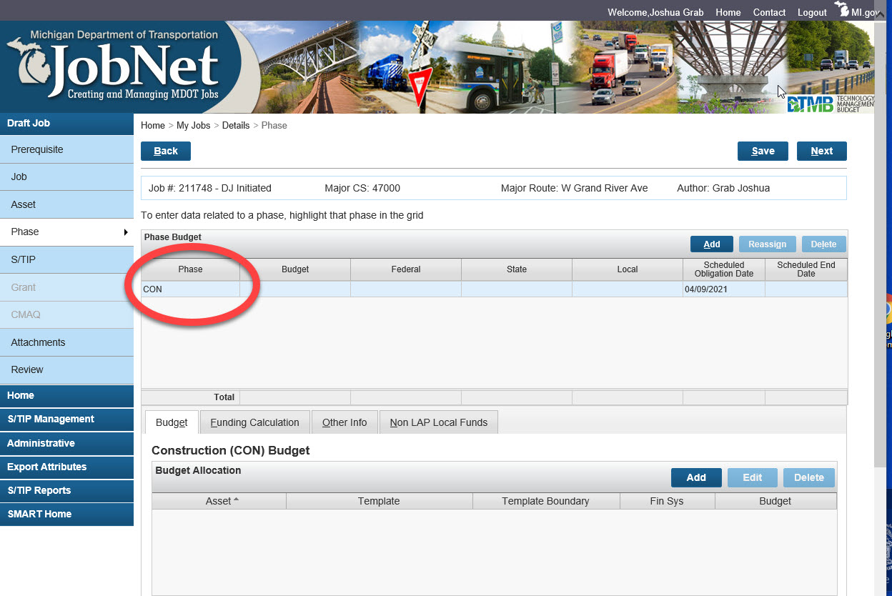
In the lower table titled “Construction (CON) Budget”, click “Add”.
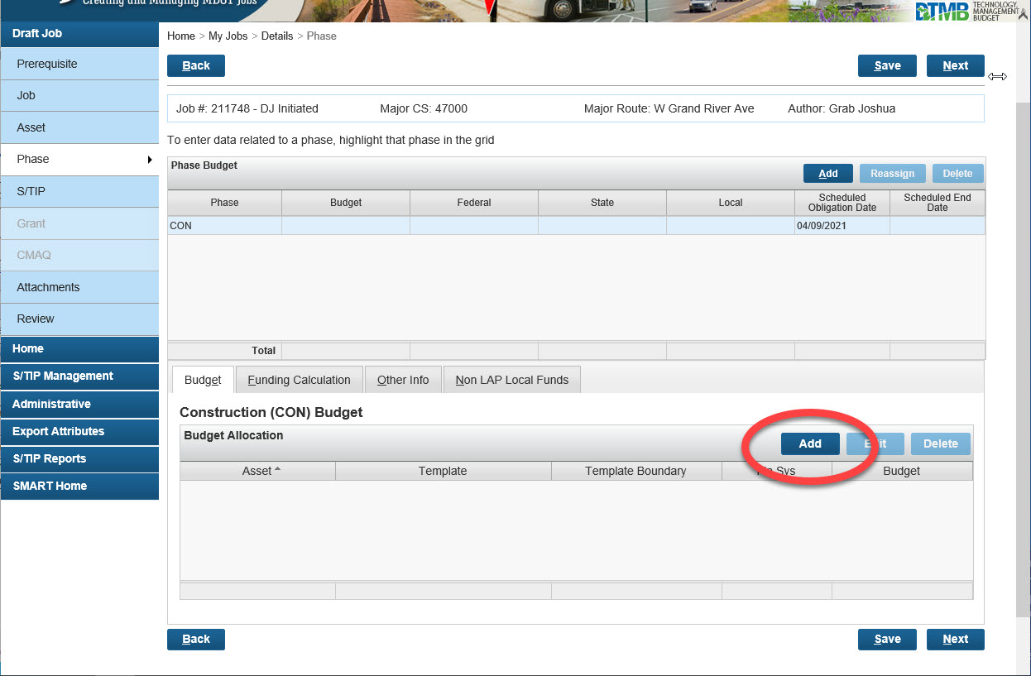
From here you will insert a budget line for each template that this job is funded with.
For this example: this example job is in Livingston County, RTF 1, and is using STP and TEDF Category D (State D) funds.
Use the dropdown boxes to choose the following:
Asset – “Road/Other”
Template – “STP - Rural/Flexible” this can be scrolled to or start by Typing “STP” in the dialog box and jump to the STP templates.
Template Boundary – Choose the RTF the job is in, in this case, “1”
Fin Sys – “STL”
Budget – Line 5 on the 1799 (10/20)
Click in an open area of the JobNet page to save the budget line.
The funding will automatically be broken down into an 80/20, Federal/Local split. If the funding of this job is split different than 80/20, it will need to be manually adjusted by doing the following:
Funding Calculation Tab
Select the “Funding Calculation” tab located next to the “Budget” tab you are currently in.
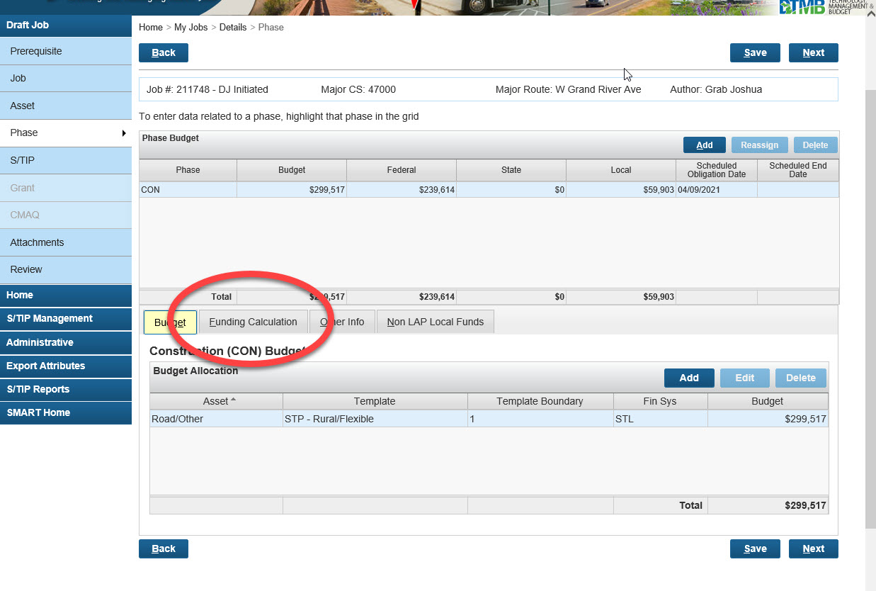

You will automatically be in the “Calculation Method” tab. Select the “Manual Calculation” button
Then, select the “Participating Work” tab.
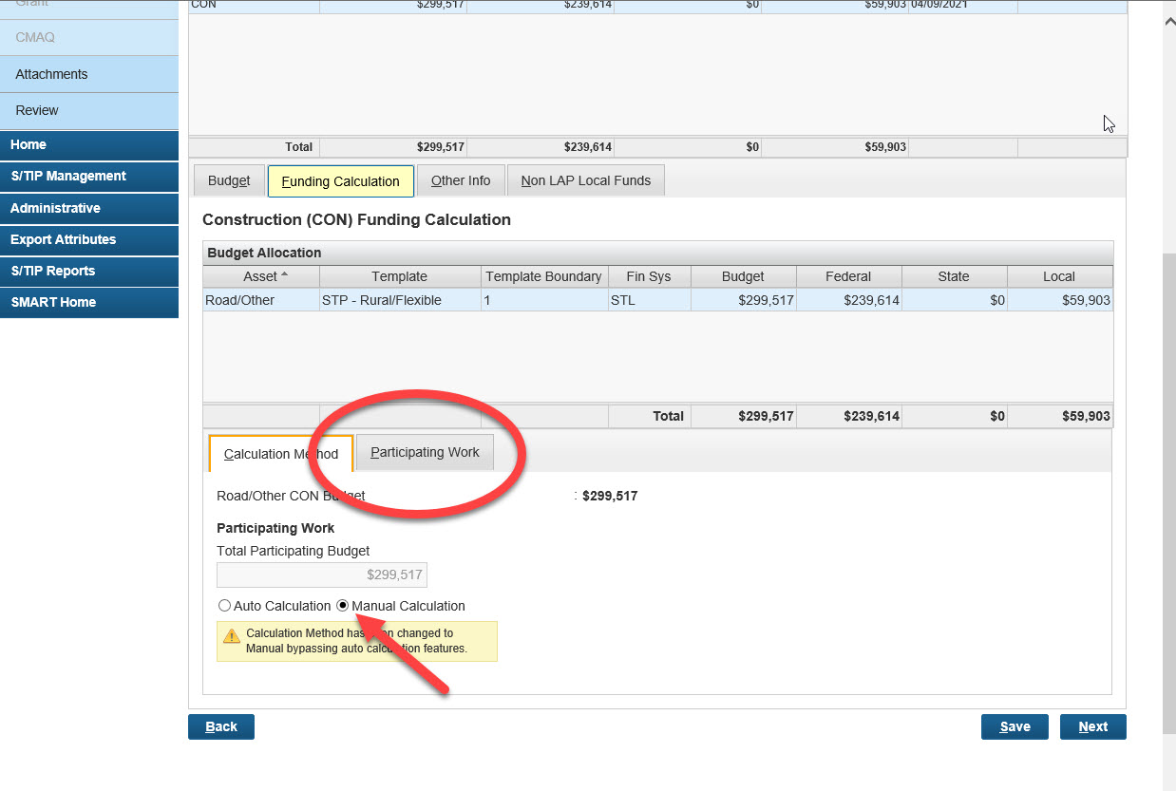

In the “Local Match Amount Information” section, select the budget line to make it blue, then select “Edit”
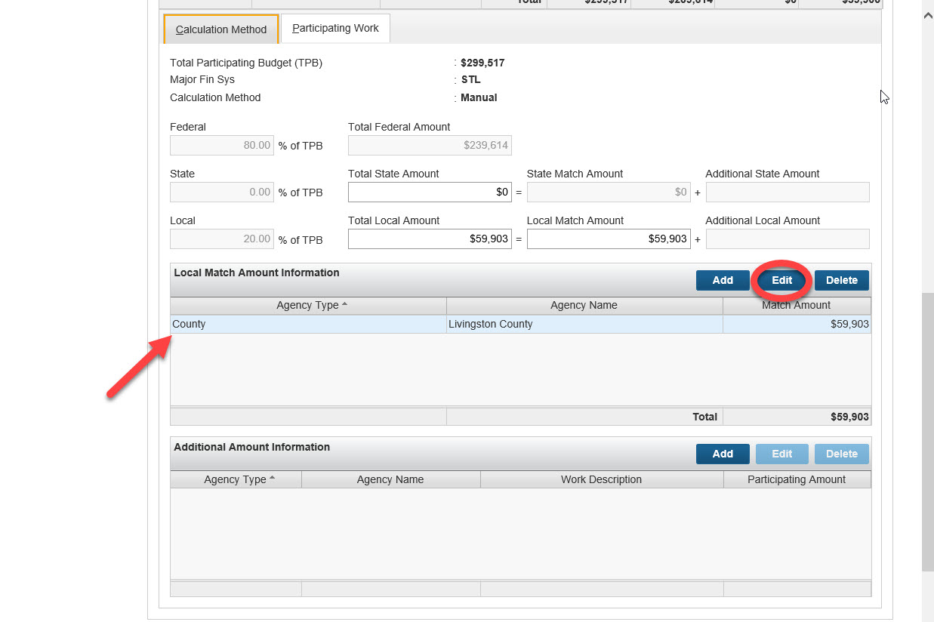

Put the “Local Match” amount from the 1799 (line 3) into the box under “Match Amount” in JobNet and click in a blank area to save this. An error will appear. To fix this error, place that same amount into the “Total Local Amount” and “Local Match Amount” boxes found just above the line you have been working in. Click in a blank area to save this information and the error should go away when all three numbers are the same.
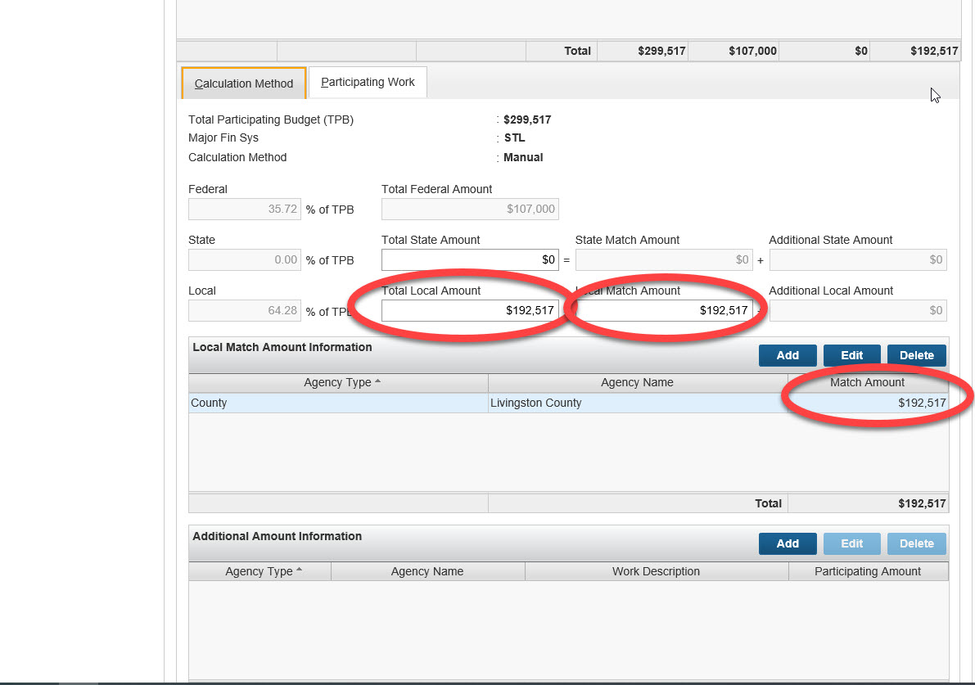
Go Back up to the “Budget” tab and select it to add another line for State D funding if needed.
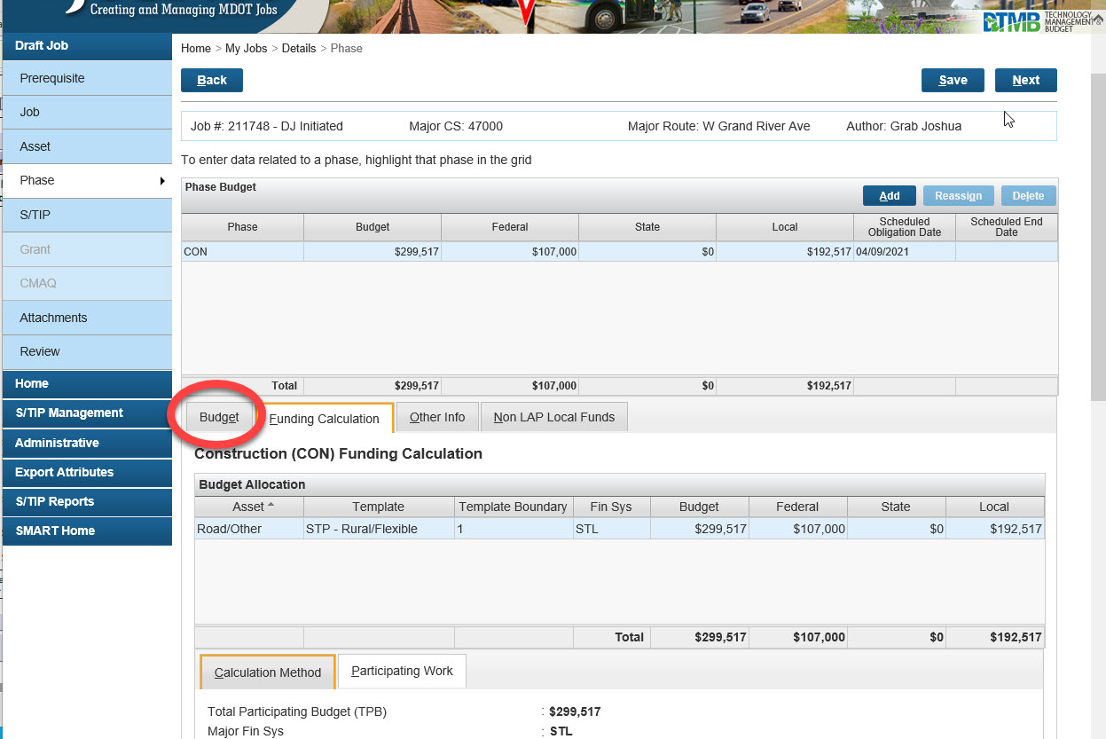

Click “Add” in the “Construction (CON) Budget” table, and another budget line will appear.
Use the dropdown boxes to choose the following:
Asset – “Road/Other”
Template – “TEDF Category D”
Template Boundary – “Livingston”. This is a new template that is now divided into the county that the Job takes place in for State D funding.
Fin Sys – “EDD”
Budget – Line 6 from the 1799 and click in a blank area to save this budget line.
The TEDF Category D budget line will auto calculate to 100% state.

Both budget lines should look like this:
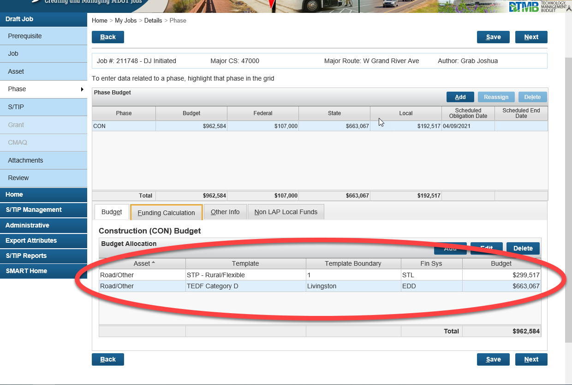

Check the top “Phase Budget” table to make sure that the “Federal”, “State”, and “Local” amounts are correct. Also, check to be certain that neither the Federal or State amount is not higher than 80% of the “Budget” or total job cost.
Other Info Tab
Click on the “Other Info” tab to the right of the “Funding Calculation tab” that you have been working in.
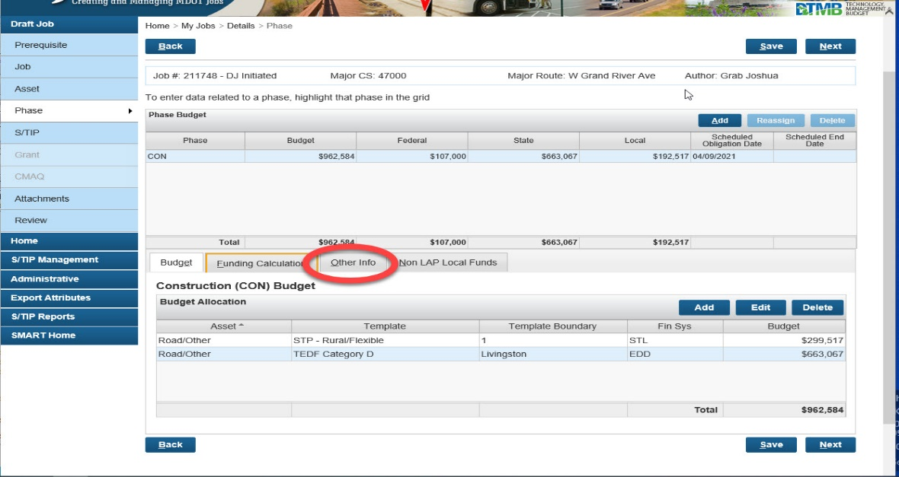
Check that the “Scheduled Obligation Date” is the same as the “Job” Page, or two months before the “Anticipated Letting Date” on the 1799.
Use the calendar to select a “Scheduled End Date”. This date should be the last day of the Fiscal Year that the job is in, September 30. Click “Save”
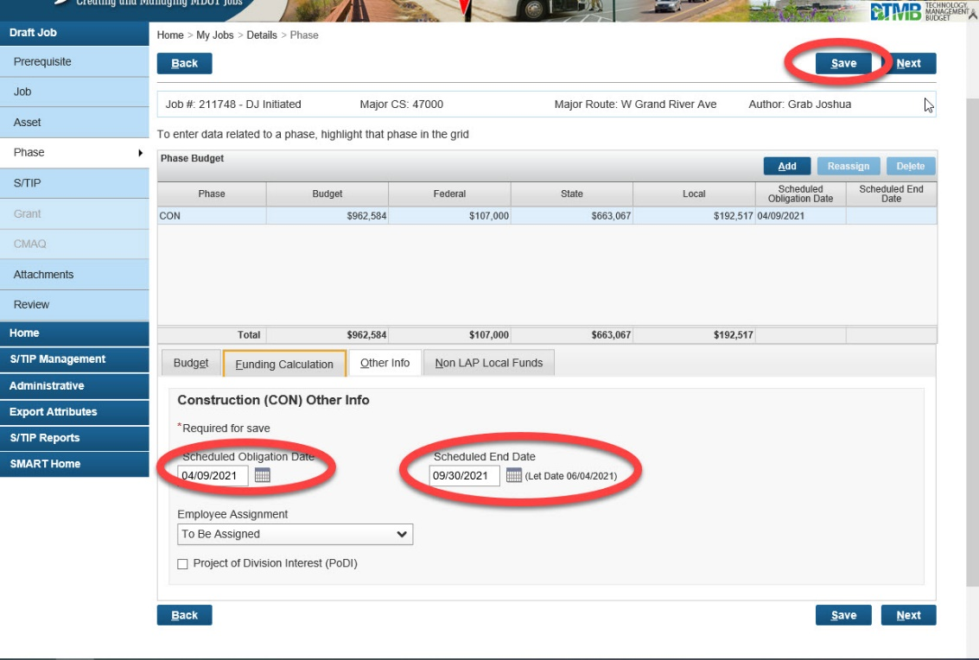
Non LAP Local Funds
Click on the “Non LAP Local Funds” tab, next to the “Other Info” tab that you have been working in. In this tab, the CE and PE percentages should automatically default to 15% and 10% respectively. If the Local Agency doing the job has provided more accurate information, we ask that you put this in now. These are lines 8a and 8b (and possibly 8c) on the 1799. To input or change the amounts, select the “Percentage” or “Fixed Amount” buttons under the “CE”, “PE”, or “Other” that you wish to change. By selecting the proper button, that box will allow itself to be updated. Update the fixed amount or percentage and click “Save”.
Note: the default is set after the first budget line is programmed so if you have a second budget line you might need to adjust the default percentages back to 15% and 10% if you are not given specific values on the 1799 form.
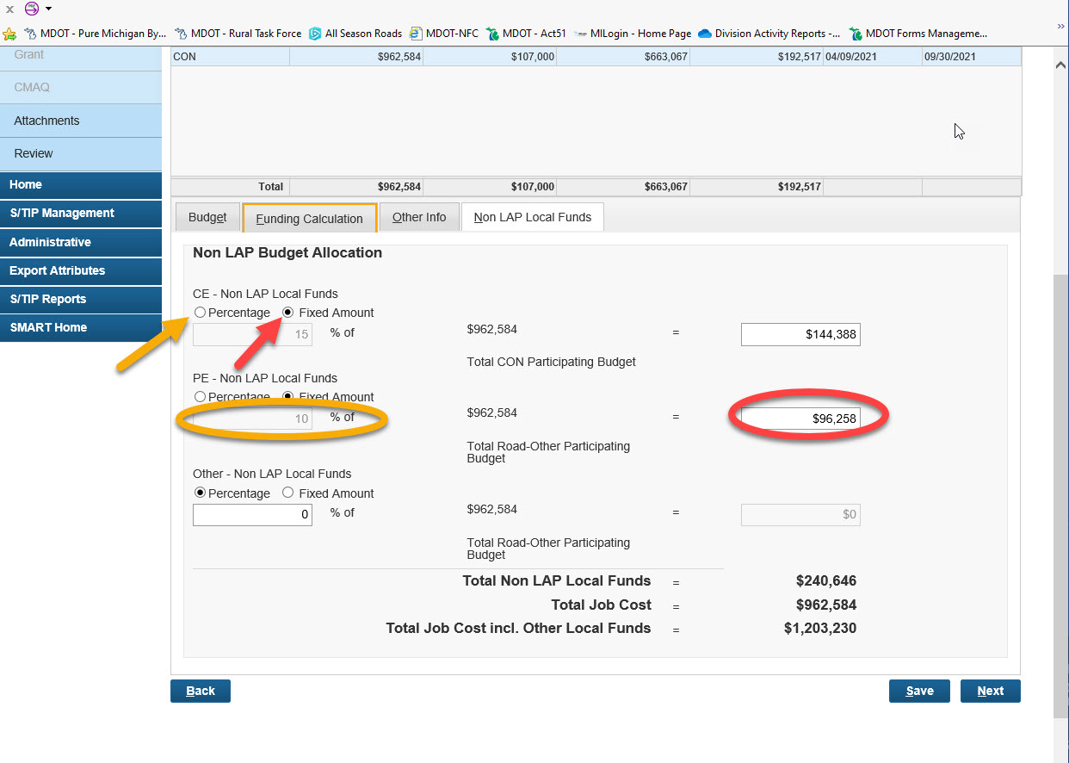
Click “Next” to go to the “S/TIP” page.
S/TIP Page
This page is filled in automatically as the job is programmed. Look this page over for accuracy.
The “Comment(s)” section at the bottom is for any notes the programmer would like to remain with this job.
Click “Next” to go to the “Attachments” page
Attachments Page
The “Attachments Page” is where the 1799(s), meeting minutes, or any other documentation will be attached in JobNet. There should be a new 1799 attached for every Draft Job and Change Request. I prefer the 1799 be attached under the “Road/Other” Category.
To attach a 1799:
Make sure the “Road/Other” line is highlighted.
Click “Choose File” and map to the 1799s location. Click “open”
In JobNet, choose “Upload”. The Attachment will appear in the middle table. The attachment will be called by its file name. I like to see the Job number and “1799” in the “File Name”. it makes it easer to sort if the job ends up with multiple Change Requests and documents attached.
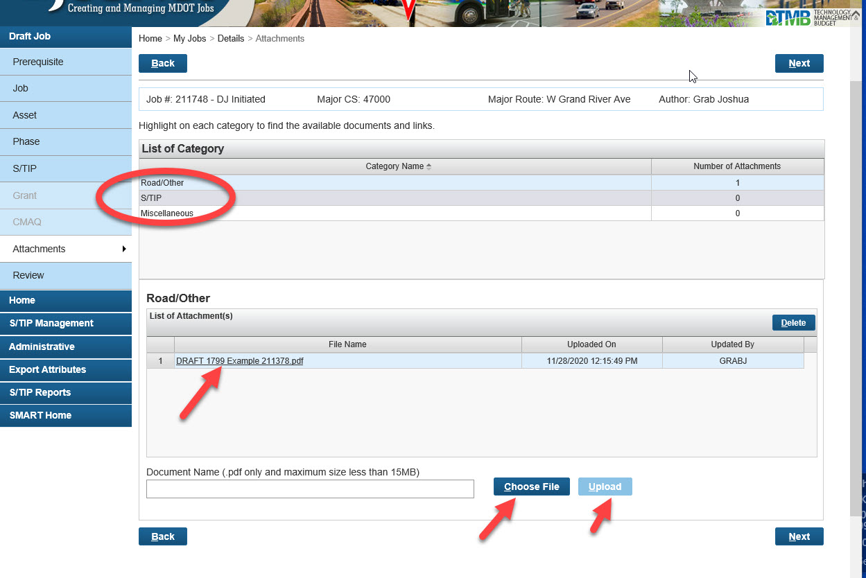Click “Next” to go to the “Review Page”
Look over the “Review Page” to be sure that all of the information is correct.

Press “Submit” to submit this Draft Job.

